Passport Automation System

Use case :

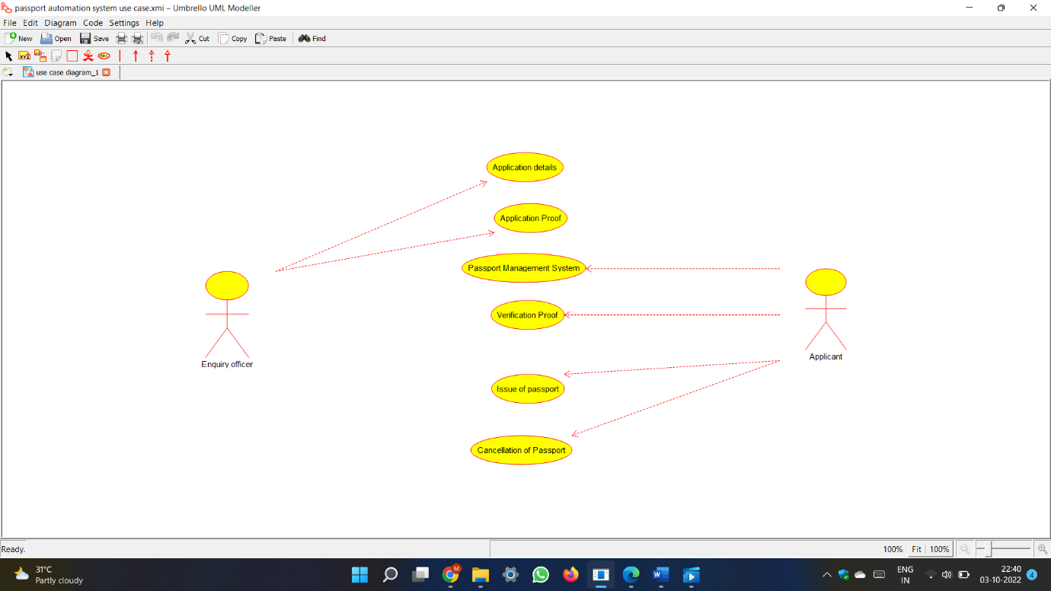

Class diagram :

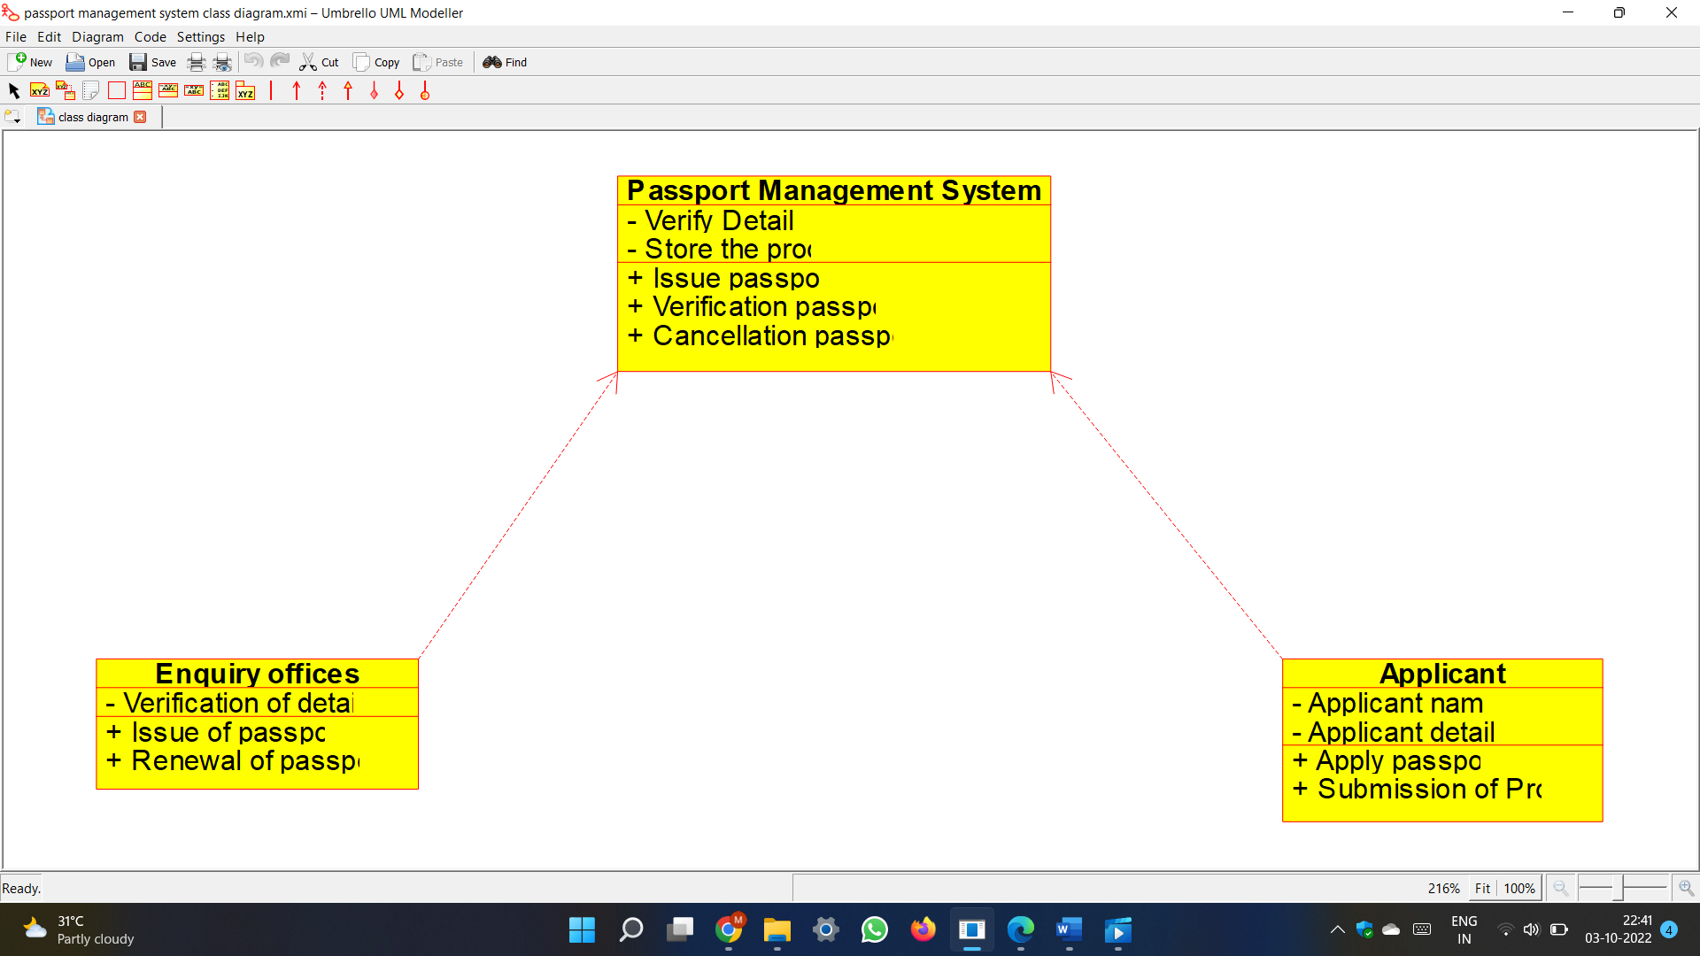

Code :

#ifndef PASSPORT_MANAGEMENT_SYSTEM_H

#define PASSPORT_MANAGEMENT_SYSTEM_H

#include <string>

/**

* class Passport_Management_System

*

*/

class Passport_Management_System

{

public:

// Constructors/Destructors

//

/**

* Empty Constructor

*/

Passport_Management_System ();

/**

* Empty Destructor

*/

virtual ~Passport_Management_System ();

// Static Public attributes

//

// Public attributes

//

// Public attribute accessor methods

//

// Public attribute accessor methods

//

/**

*/

void Issue_passport ()

{

}

/**

*/

void Verification_passport ()

{

}

/**

*/

void Cancellation_passport ()

{

}

protected:

// Static Protected attributes

//

// Protected attributes

//

public:

// Protected attribute accessor methods

//

protected:

public:

// Protected attribute accessor methods

//

protected:

private:

// Static Private attributes

//

// Private attributes

//

void Verify_Details;

void Store_the_proof;

public:

// Private attribute accessor methods

//

private:

public:

// Private attribute accessor methods

//

/**

* Set the value of Verify_Details

* @param new_var the new value of Verify_Details

*/

void setVerify_Details (void new_var) {

Verify_Details = new_var;

}

/**

* Get the value of Verify_Details

* @return the value of Verify_Details

*/

void getVerify_Details () {

return Verify_Details;

}

/**

* Set the value of Store_the_proof

* @param new_var the new value of Store_the_proof

*/

void setStore_the_proof (void new_var) {

Store_the_proof = new_var;

}

/**

* Get the value of Store_the_proof

* @return the value of Store_the_proof

*/

void getStore_the_proof () {

return Store_the_proof;

}

private:

void initAttributes () ;

};

#endif // PASSPORT_MANAGEMENT_SYSTEM_H

#ifndef ENQUIRY_OFFICES_H

#define ENQUIRY_OFFICES_H

#include <string>

/**

* class Enquiry_offices

*

*/

class Enquiry_offices

{

public:

// Constructors/Destructors

//

/**

* Empty Constructor

*/

Enquiry_offices ();

/**

* Empty Destructor

*/

virtual ~Enquiry_offices ();

// Static Public attributes

//

// Public attributes

//

// Public attribute accessor methods

//

// Public attribute accessor methods

//

/**

*/

void Issue_of_passport ()

{

}

/**

*/

void Renewal_of_passport ()

{

}

protected:

// Static Protected attributes

//

// Protected attributes

//

public:

// Protected attribute accessor methods

//

protected:

public:

// Protected attribute accessor methods

//

protected:

private:

// Static Private attributes

//

// Private attributes

//

void Verification_of_details;

public:

// Private attribute accessor methods

//

private:

public:

// Private attribute accessor methods

//

/**

* Set the value of Verification_of_details

* @param new_var the new value of Verification_of_details

*/

void setVerification_of_details (void new_var) {

Verification_of_details = new_var;

}

/**

* Get the value of Verification_of_details

* @return the value of Verification_of_details

*/

void getVerification_of_details () {

return Verification_of_details;

}

private:

void initAttributes () ;

};

#endif // ENQUIRY_OFFICES_H

#ifndef APPLICANT_H

#define APPLICANT_H

#include <string>

/**

* class Applicant

*

*/

class Applicant

{

public:

// Constructors/Destructors

//

/**

* Empty Constructor

*/

Applicant ();

/**

* Empty Destructor

*/

virtual ~Applicant ();

// Static Public attributes

//

// Public attributes

//

// Public attribute accessor methods

//

// Public attribute accessor methods

//

/**

*/

void Apply_passport ()

{

}

/**

*/

void Submission_of_Proof ()

{

}

protected:

// Static Protected attributes

//

// Protected attributes

//

public:

// Protected attribute accessor methods

//

protected:

public:

// Protected attribute accessor methods

//

protected:

private:

// Static Private attributes

//

// Private attributes

//

void Applicant_name;

void Applicant_details;

public:

// Private attribute accessor methods

//

private:

public:

// Private attribute accessor methods

//

/**

* Set the value of Applicant_name

* @param new_var the new value of Applicant_name

*/

void setApplicant_name (void new_var) {

Applicant_name = new_var;

}

/**

* Get the value of Applicant_name

* @return the value of Applicant_name

*/

void getApplicant_name () {

return Applicant_name;

}

/**

* Set the value of Applicant_details

* @param new_var the new value of Applicant_details

*/

void setApplicant_details (void new_var) {

Applicant_details = new_var;

}

/**

* Get the value of Applicant_details

* @return the value of Applicant_details

*/

void getApplicant_details () {

return Applicant_details;

}

private:

void initAttributes () ;

};

#endif // APPLICANT_H

Activity diagram :

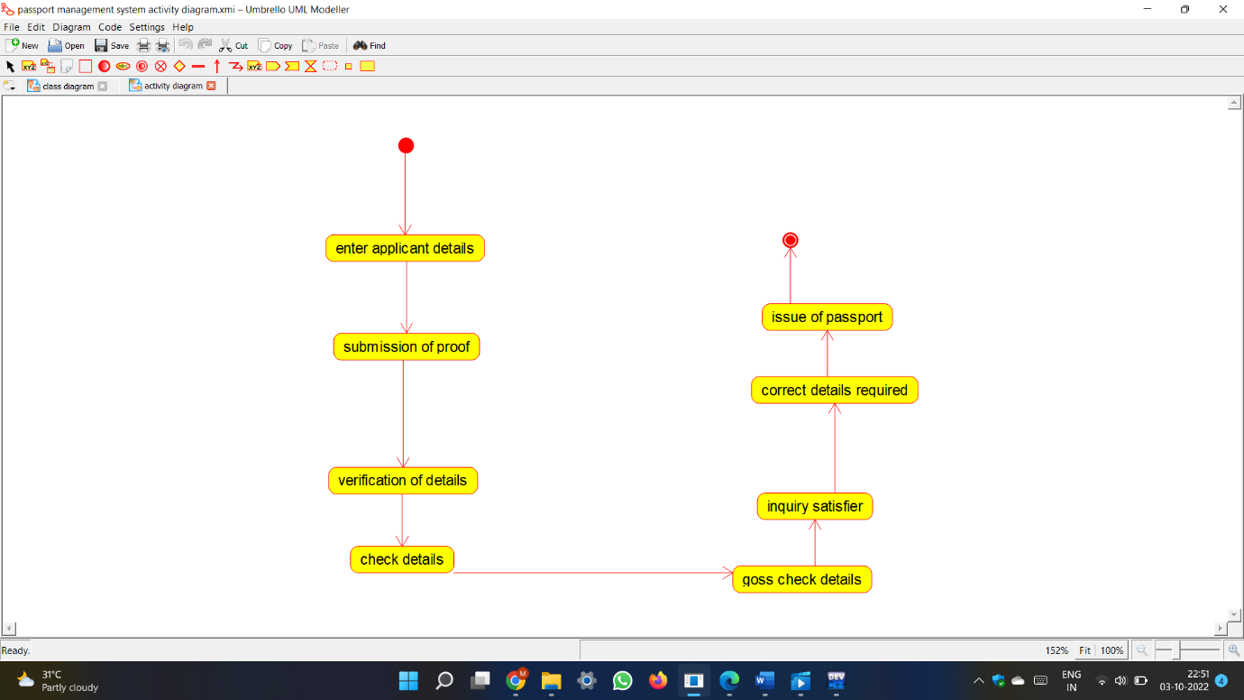

State chart diagram :

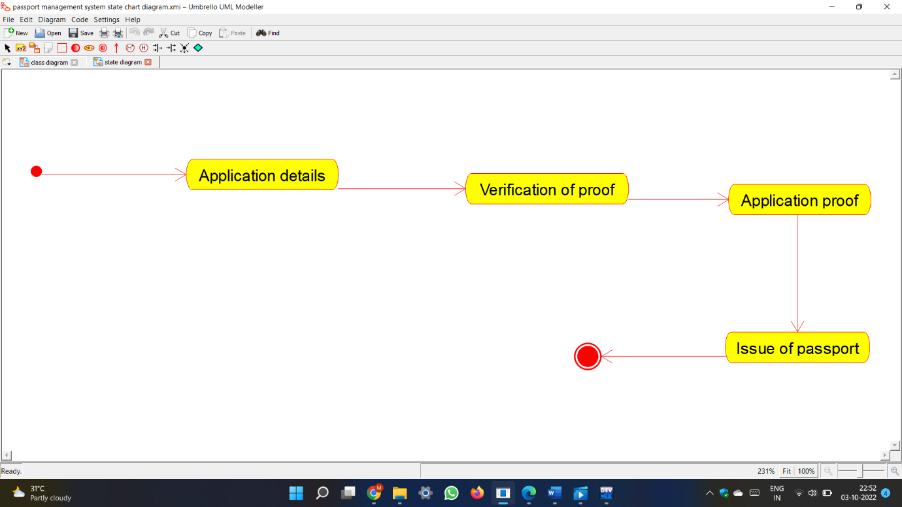

Sequence diagram :

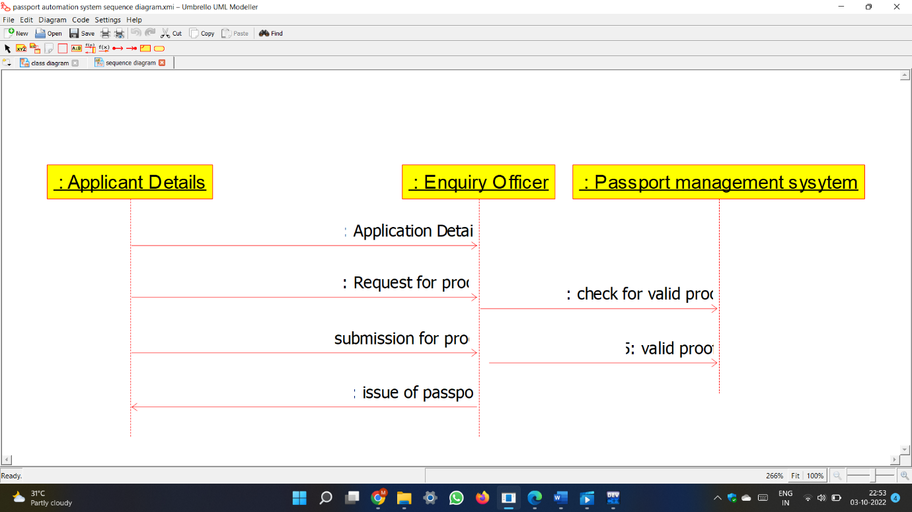

Deployment diagram :

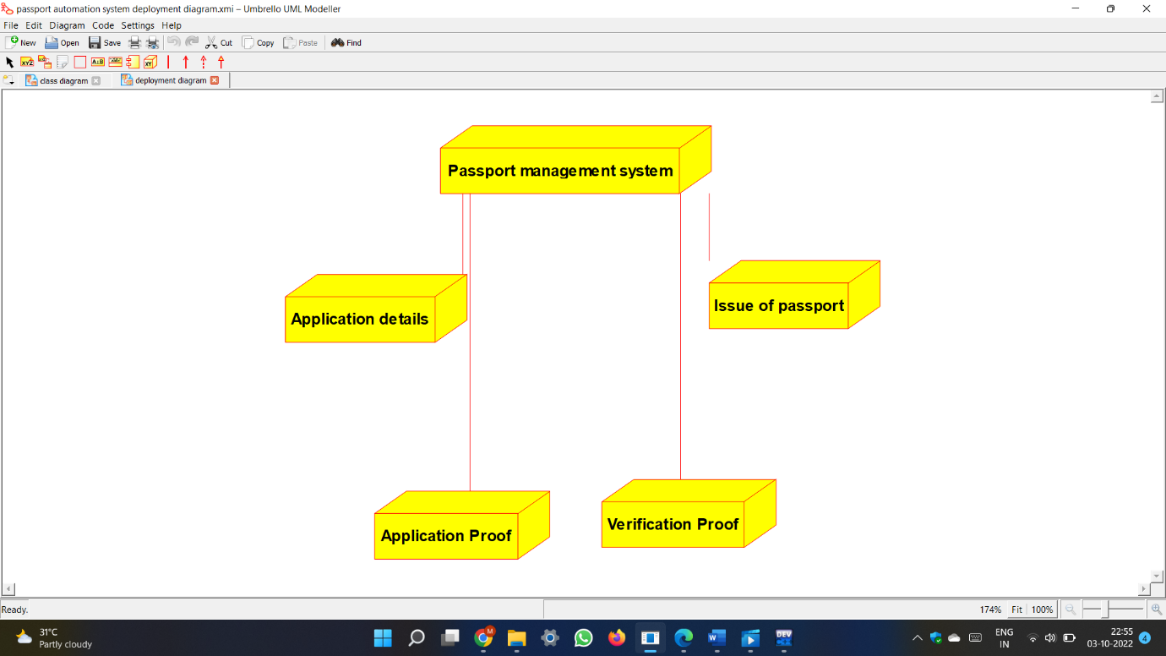

Component diagram :

